**Personas, Problem Scenarios, and Propositions**

*Paulo Cardoso*

14/09/2016

1. **Positioning Statement**

For Bla (Telecom company, provides Land lines, Internet, Cable TV and Mobile Phones) TV and Internet customers who desires access OTT content from several sources in a single place, the Bla Play is a OTT aggregator that provides in a single portal access to VOD content from more than 10 providers (HBO, TNT, FOX...). Unlike Netflix, our product we are not restricted to only one library of content we can provide access for more than 20.000 media assets through the metadata aggregation and proprietary SVOD and TVOD content.

* 1. **Brainstorm Personas**
* Ana the Video Producer (Youtuber)
* André the High School Student
* Samantha the College Grad Student
* Janete the Housewife
* Mario the Mechanic
* Alf the Bla Play Product Manager
  1. **Detail a Persona**
* Ana the Video Producer (Youtuber):

Ana is a Video Maker, she produces media content for the Youtube. Her Channel is centered on Critical Reviews and Recommendations of Movies and TV Shows, she is graduated on Arts and has 7 years of experience as Youtuber.

Ana has a Youtube channel where post their videos, her channel has more than 1 million subscribers, 200 videos and five million views from around the world. On her profession one of the mandatory rules is that she always need to be well informed about the media content that is on the OTT platforms across the internet. She also needs to be able to watch this VOD content that is distributed across several platforms.

Ana is a Oi TV and Internet customer, that means Oi provides Cable TV and Internet do Ana, Ana works from home so she has only one account with Oi.

|  |  |
| --- | --- |
| Thinks | Ana would like to have access to all OTT content from all providers in a single platform. |
| Sees | Ana sees that all OTT content is spread across several proprietary OTT media platforms; what make her job difficult. |
| Feels | She feels frustrated because even though all providers make their OTT content available for Oi TV and Internet customers, this same content is spread across several platforms and is impossible for search for this content in a single platform. |
| Does | So she has do every day search on all OTT platforms for updates on their inventory. Spending precious time on this task, what makes her job difficult and take longer to be completed. |

* 1. **Problem Scenario, Current Alternative and Value Propositions**

|  |  |  |
| --- | --- | --- |
| Problem Scenario | Current Alternative | Value Proposition |
| She wants to be able to search by all OTT platforms in single environment. | Currently she has to search in all platforms individually. | Oi Play OTT Aggregator will provide A search mechanism that allows anyone to search on all OTT providers registered on the service. |
| She would like to not have to login on each OTT platform individually. | Currently she is obligated to login on each one OTT platform. | Oi Play should provide an Single Sign On system that enable the login on all OTT platform in an invisible way to the user. |
| She also would like to find the TV Guide for all Oi Cable TV Channels in a single place. | Currently she has to access each channel on the TV or his respective web site to know which movie or TV show will be presented on each schedule on each Channel. | Oi Play will provide an TV Guide to present all Schedule for Cable TV for 15 days in the future. |

1. **User Story**

|  |  |
| --- | --- |
| Story | Test Case |
| As a Youtuber, I want to search by newest assets so that I know which the newest assets on all OTT platforms libraries are. | Make sure that is possible search OTT assets by date.  Make sure that is possible search on all producers (HBO, TNT, FOX...) OTT platforms. |
| As a Youtuber that is a registered and logged user of Oi Play, I want to be able to access the OTT asset so that I can watch the asset. | Make sure that the OTT asset is available on the partner OTT platform.  Make sure that the user has privilege to  access this specific asset.  Make sure that the user is logged on the  partner OTT platform. |
| As a Youtuber that is an Oi TV and Internet customer, I want to be able to make just one login so that I can access all the OTT content on Oi Play. | Make sure to login the user on the partner OTT platform before transfer the user to the asset player page.  Make sure that the user has access privileges to this partner OTT platform. |
| As a Youtuber that makes videos of recommendations of Movies and TV shows, I want to be able to see the TV Guide of 15 days in the future so that I can make recommendations about what to watch, which channel and when. | Make sure that the Metadata provider is making regular updates on the TV Guide metadata.  Make sure that Oi Play is updated with the last version of the metadata.  Make sure that the TV Guide feature is working properly.  Make sure that the TV Guide is completed of Channels and updated to cover 15 days in the future. |
| As a Youtuber that is entitle to have access to all OTT content on Oi Play, I want access available for all the Partners SVOD platforms (HBOGO, TNTGO, FOX Play...), and proprietary SVOD (Coleção Oi) so that I can make fully use of my TV and Internet plan. | Make sure that the user is entitled to access all SVOD platform.  In case of the user be entitled to access all SVOD platforms, make sure that all platforms are available for him.  Make sure that all Metadata that describes the VOD assets of the partners is updated with the right links and deeplinks. |

1. **Storyboard**

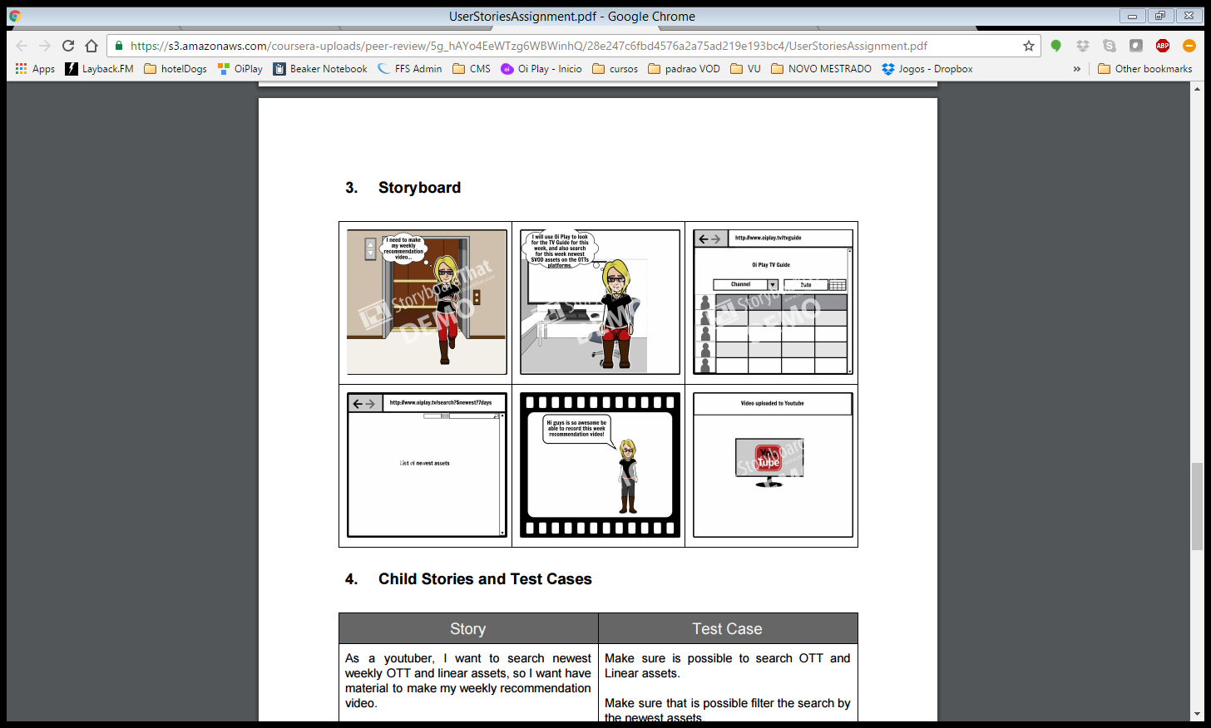

1. **Child Stories and Test Cases**

|  |  |
| --- | --- |
| Story | Test Case |
| As a user, I want to search newest weekly OTT and linear assets, so I want have material to make my weekly recommendation video. | Make sure is possible to search OTT and Linear assets.  Make sure that is possible filter the search by the newest assets. |
| As a user, I want use Oi Play to search for the newest linear assets and I want this result on a guide showing the schedule and channel where those assets are going to be presented. | Make sure that is possible to search newest assets from linear channels.  Make sure that the results of search on linear assets return in guide of schedule and channels. |
| As a user, I want use Oi Play to search for the newest VOD assets and I want the response for those assets in a listed. | Make sure that is possible to search newest assets from VOD suppliers.  Make sure that the results of search on VOD assets return in list. |

1. **Testable Assumptions**

|  |  |  |  |  |  |
| --- | --- | --- | --- | --- | --- |
| **Project position statement**  For Bla (Telecom company, provides Land lines, Internet, Cable TV and Mobile Phones) TV and Internet customers who desires access Over the Top (OTT) content from several sources in a single place, the Bla Play is a OTT aggregator that provides in a single portal access to Video on Demand (VOD) content from more than 10 providers (HBO, TNT, FOX...). Unlike Netflix, our product we are not restricted to only one library of content we can provide access for more than 20.000 media assets through the metadata aggregation and proprietary Subscription Video on Demand (SVOD) and Transactional Video on Demand (TVOD) content. | | | | | |
| **Core/Summary Value Hypothesis**  If we aggregate OTT providers, Subscription Video on Demand (SVOD) and Transactional Video on Demand (TVOD) for Bla customers, we will have develop a personalized platform that provides the best and most complete Video Digital Assets library. | | | | | |
| **Testable Child Assumptions**  If we provide access to third partner content (HBO, TNT…) for Bla customers, they will stay on our platform 18% in average.  If we provide a titles recommendation for the users based on usage, they will they will stay 10% more time on the platform.  If we provide the possibility of use of Bla Login System (OAuth 2) for Bla customers, they will be 25% more willing to make the first login.  If we filtering tool were available for users, they will feel an improvement on the usability.  If we provide a Subscription Video on Demand service and have a recommendation toll we could try sell PPV/Push VOD e TVOD for Bla customers, they will be more willingly to buy other premium assets. | | | | | |
| **Priority** | | **T**ype of assumption (Pivotal, child of a pivotal, child of a child of a pivotal; extremely important, important, tactical; not sure) | | **Explanation for the Ranking** | |
| 1 | | **Pivotal** - If we provide access to third partner content (HBO, TNT…) for Bla customers, they will stay on our platform 18% in average. | | The main idea is to keep the user on the platform. | |
| 2 | | **Pivotal** – If we provide the possibility of use of Bla Login System (OAuth 2) for Bla customers, they will be 25% more willing to make the first login. | | The login system will provide access to third partner OTT platform and payment gateway. | |
| 3 | | **Pivotal** - If we provide a Subscription Video on Demand service and have a recommendation toll we could try sell PPV/Push VOD e TVOD for Bla customers, they will be more willingly to buy other premium assets. | | The selling of those assets can bring additional revenue. | |
| End truly pivotal assumptions | | | | | |
| 4 | | | **Tactical** – If we provide a titles recommendation for the users based on usage, they will they will stay 10% more time on the platform. | Recommendation is a core feature that amplifies the accuracy based on user usage of the platform. | |
| 5 | | | **Child** - If we filtration tool for users, they will feel an improvement on the usability. | These feature is useful but not a priority | |
| **#** | **Priority** | | **Key Assumption** | | **Test Vehicles** |
| 1 | 1 | | If we provide access to third partner content (HBO, TNT…) for Bla customers, they will stay on our platform 18% in average. | | Wizard of Oz: Get the user to the page, and we explain the service and see if at least 10% seems interested and begins to browser through the platform. |
| Concierge: We build up a simple site just with the top 100 assets available on the library, selected manually to favour paid assets. |
| MVP: Time to time give access to third partner content to new users to attract them. |
| 2 | 2 | | If we provide the possibility of use of Bla Login System (OAuth 2) for Bla customers, they will be 25% more willing to make the first login. | | Wizard of Oz: We send an email to Bla Customers to let them aware of the service. |
| Concierge: Offer also the possibility to login with social media login. |
| MVP: Add a button login and after clicked display the login options. |
| 3 | 3 | | If we provide a Subscription Video on Demand service and have a recommendation toll we could try sell PPV/Push VOD e TVOD for Bla customers, they will be more willingly to buy other premium assets | | Wizard of Oz: configure the recommendation tool to favour paid assets |
| Concierge: Offer bundle of paid content |
| MVP: Give 10% off on the second buy |

1. **Key Questions**

|  |  |
| --- | --- |
| **Key questions for personas & Problem scenarios sprint** | |
| What general population(s) and problems do we want to learn about? | We want to know if the effort to integrate with a payment gateway to allow TVOD - Transactional VOD will have a positive effect on Bla Play business. |
| What screener did we use for subjects? | **Registered user**: Do you would like to have access to newest Movies and TV Shows with a new TVOD - Transactional VOD?  **Not Registered user**: Access to newest Movies and TV Shows would influence your choice to join us? |
| Where did we (will we) recruit subjects? | Among Bla Play visitors, some moment during the navigation on the portal a pop up would appear asking to answer the questions above. |

|  |  |
| --- | --- |
| **Key questions for motivation sprint** | |
| What is the basic/summary value hypothesis we’re testing? | If we aggregate the most popular TV Cable Channels OOTs and also offer SVOD and TVOD content Bla Play will provide most significant user experience and in consequence will bring a good impact on the revenue and amount of registered users. |
| What are the specific hypotheses and experiment vehicles we plan to test? Pick your top choice (1) of experiment vehicle for each assumption. | If we provide the aggregation of the most popular TV Cable Channels OOT platforms in terms of content and login for Bla Telecom Customers they will look for this kind of entertainment majorly on Bla Play, increasing Bla Play user base. **Test vehicle**: Set up a Google Analytics account to track access. **We need**: traffic of at least 10% of Bla Customer base.  If we provide in addition to the OTT we also provide an SVO and TVOD library with up to10000 assets for Bla Telecom Customers they will became a subscriber, increasing Bla Play user base and revenue. **Test vehicle**: Through the use of Google Analytics and Subscription reports to analyze the impact. **We need**: Increase user base on 1% increase revenue of 15%. |

|  |  |
| --- | --- |
| **Key questions for usability sprint** | |
| What are the user stories we’re working? | As Ana the Video Producer (Youtuber), I want to have access to the latest TV Channel OTT assets on a single platform so that I can facilitate my researches of OTT content.  As Ana, I want to have easy access to most recent movies (TVOD) from anywhere (that has internet access), so that I can perform the researches from my videos how and where I want.  As Ana, I want to have more than one way to pay (credit card and co-billing with Bla Play Telecom) for SVOD and TVOD services, so that I can choose how to pay.  As Alf the Bla Play Product Manager, I want to have tools to analyze the portal focused on the logged users, so that I can better understand the patterns of consumption on the portal. |
| What are the major interface chunks or jobs we need to prototype (ex: a calendar a group of users can edit and share)? How do these relate to the stories above? | **OTT, SVOD and TVOD library aggregation**:   * The OTT content will be displayed inside Channels Section and each Channel will have a playlist and each asset an asset description page. * SVOD content will be displayed on SVOD section, will be organized on genre playlists and the assets will have an asset description page with a player embedded. * TVOD content will be displayed on a playlist on the main page and the assets will have an asset description page with an embedded player.   **Payment Gateway**:   * To be used on SVOD subscription and TVOD purchases, should allow the following payment methods: Credit Card and Co-billing with Bla Telecom   **Report Area**:   * To be used by Bla Play Staff to generate reports to Bla Telecom, should display all tracked user activities centered on each user.   **Platform**:   * All features and services provided by Bla Play should be available for Web Browser, Android and IOS. |

|  |  |
| --- | --- |
| **Key questions for an architecture sprint** | |
| What are the personas and user stories we’re working? | As Ana the Video Producer (Youtuber), I want to have access to the latest TV Channel OTT assets on a single platform so that I can facilitate my researches of OTT content.  As Ana, I want to have easy access to most recent movies (TVOD) from anywhere (that has internet access), so that I can perform the researches from my videos how and where I want.  As Ana, I want to have more than one way to pay (credit card and co-billing with Bla Play Telecom) for SVOD and TVOD services, so that I can choose how to pay.  As Alf the Bla Play Product Manager, I want to have tools to analyze the portal focused on the logged users, so that I can better understand the patterns of consumption on the portal. |
| What are the major chunks or jobs we need to build or find in a third party module (ex: a calendar a group of users can edit and share)? How do these relate to the stories above? | **OTT, SVOD and TVOD library aggregation**:   * View: Clean portal, composed of sections, playlists and detail page. * Controller: The asset control will be made using its unique ID. * Model: Develop CMS capable to ingest all three kinds of assets.   **Payment Gateway**:   * View: Bla Telecom Payment Gateway has to have a clean layout, be of easy operation and allow the logged user to choose the payment format between Credit Card and Co-Billing. * Controller: As an API this Payment Gateway will need some exchanges of messages between the Bla Play and the payment service. So develop this integration is a main priority. * Model: Store all transactions with all information available to enrich the reports.   **Report Area**:   * View: Will be possible to observe all users activities on the portal in details. * Controller: Every action of the logged user on the portal should be tracked and logged for further analysis. * Model: Development of back end to allow storage of user activities centered on the user ID.   **Platform**:   * View: The front end will need to be developed in a way that all platforms have same look and feel. * Controller: The services should be developed on a way that is accessible to all platforms * Model: The back end should support the services for all three platforms |

1. **Next Steps**

|  |  |
| --- | --- |
| **Hypothesis/Sprint Topic** | **Validation Notes** |
| Persona & Problem hypotheses | Ana the Video Producer is a Video Maker, she produces media content for the Youtube. Her Channel is centered on Critical Reviews and Recommendations of Movies and TV Shows.  She wants to be able to search by all OTT platforms in single environment. And also have access to SVOD and TVOD assets.  Alf the Bla Play Product Manager, he is responsible for create and implement strategies to grow Bla Play. He wants a report area that to be able to understand better the users activities on the portal.  **Our notes**: to provide all those features requested by Ana e Alf plenty of development is needed, so some kind of prioritization will be needed to deal with this issue. |
| Value hypothesis | “If we aggregate the most popular TV Cable Channels OOTs and also offer SVOD and TVOD content Bla Play will provide most significant user experience and in consequence will bring a good impact on the revenue and amount of registered users.”  **Our notes**: to be able to quantify these increases a report area will be needed. |
| Usability hypothesis | As Ana the Video Producer (Youtuber), I want to have access to the latest TV Channel OTT assets on a single platform so that I can facilitate my researches of OTT content.  As Ana, I want to have easy access to most recent movies (TVOD) from anywhere (that has internet access), so that I can perform the researches from my videos how and where I want.  As Ana, I want to have more than one way to pay (credit card and co-billing with Bla Play Telecom) for SVOD and TVOD services, so that I can choose how to pay.  As Alf the Bla Play Product Manager, I want to have tools to analyze the portal focused on the logged users, so that I can better understand the patterns of consumption on the portal.  **Our notes**: To validate those features and interface a wired framed and a mockup of the screens needed will be created. |
| Architecture hypothesis | **Epics**:   * OTT, SVOD and TVOD library aggregation   + CMS/backend   + Metadata ingestion methods * Payment Gateway   + Integration with Bla Telecom Payment Gateway * Report Area   + Track and log of user activities   + Develop export data feature to export logs on several format to facilitate further integrations   + Presentation of data gather of user activities * Platform   + Frontend Web browser   + Frontend Android app   + Frontend IOS app |
| **The next sprint should be….** | **Because….** |
| The next sprint will be a motivation sprint. | Due to the amount of developments needed a motivation sprint should be done to prioritization of developments. |